Tutorial for installing Ubuntu and ROS

IN THIS TUTORIAL WE WILL INSTALL AND USE THE PREVIOUS VERSION OF ROS – MELODIC!

UNFORTUNATELY, NOT ALL OF THE PACKAGES WE WILL USE LATER ARE RELEASED YET FOR NOETIC – THE LATEST VERSION OF ROS!

Install Vmware workstation player (latest version, at the moment 16) from:
https://www.vmware.com/products/workstation-player/workstation-player-evaluation.html

Download Ubuntu desktop full Ubuntu 18.04 LTS - (LTS stands for long-term support — which means five years) from:
https://ubuntu.com/download/desktop
or from: https://old-releases.ubuntu.com/releases/18.04.5/?_ga=2.165993915.403745250.1631858955-277954797.1610534225

Start VM player and click Create virtual machine
Choose the downloaded Ubuntu 18.04 iso file

In Virtual Machine Settings:

Set RAM: depending on the ram available on your computer, give the Virtual Machine plenty of RAM (min 4 GB… If it is 16 give it 8 or even 12 GB)

Set the Network to Bridged and tick the tick mark in front of:
- replicate physical network connection state

Click “Create”

After the installation:

Login:

Splash screen:
Online accounts - skip
Live patch - click Skip (mainly for servers, we don't want updates while the robot is moving)
Help improve ubuntu - choose "no, don't send system info" (We do not want extra network traffic while robot is moving)
Location services - Off (same reason), click Next

click Done

Software updater window will pop on the screen
click "Install Now" to install the pending updates
Updater minimizes to the left in the vertical menu
Click on the Software Update icon in the vertical menu to see the progress
When updates are done press "Restart now"
If the Software Updater did not start in some reason:
To install updates, open the Update Manager by pressing ‘Alt+F2’, then enter ‘update-manager’ and hit Enter.

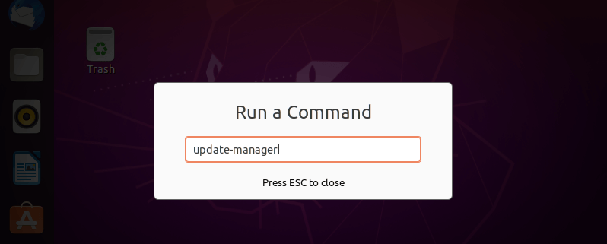

Alternatively you can update/upgrade using the following commands in the terminal:

sudo apt-get update && sudo apt-get dist-upgrade

- Log in after the reboot

The Ubuntu screen in the Vmware window will be small this time… (Vmware issue)
Minimize the VMware player window from the top right, then maximize it from the task bar. The Ubuntu screen should be full size in the VMware window.
Note: You can go full screen from the Vmware menu - the fourth button on the top left.

NOTE: The Settings menu is located in the drop down menu on the top right on the screen (icon with screwdriver and wrench)

- Configure time zone (double check if it was configured properly while the installation – should be Sofia, Bulgaria)
IMPORTANT NOTE: ROS is a distributed meta operating system, which means that ROS packages can run on multiple machines on the same IP network (on the robot and on your PC at the same time for example). In order to do so, on all computers running ROS, the time should be synchronized! The easiest way to do so is to set time to update from an NTP (Network Time Protocol) server. That's why it is very important to configure the same time zone on all computers (including the computer on the robot)!

From: Settings → Details → Date & Time
CHOOSE:
automatic date&time ON
time zone: Sofia, Bulgaria

TWEAKS:

Now we'll make some tweaks to make the Linux more Windows like, as all we are mainly Windows users

- Configure Dock position

(Dock is the equivalent of taskbar in Windows)

in Settings → Dock
CHOOSE position on screen - BOTOM
Optionally, you could enable Auto-hide the Dock

DISABLE SCREENSAVER
in Settings → Power
CHOOSE (Power saving) Blank screen - NEVER

- CHANGE THE BACKGROUND PICTURE:
(based on your preference)

For example: In Background on the left menu, click on Background and change the background picture to the one with the grey background.

HOW TO OPEN A TERMINAL

the easiest way to open terminal window on Ubuntu 18.04 desktop is to use the shortcut CTRL+ALT+T. Entering this shortcut will instantly open the terminal window.

Alternatively click the icon on the bottom right:

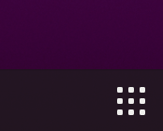

this will open the programs menu, type terminal and click on the terminal icon to open the terminal
or Right Click anywhere on your desktop wallpaper and select Open Terminal.

NOTE: IN ORDER TO PASTE TEXT IN THE LINUX TERMINAL, USE THE RIGHT MOUSE CLICK MENU OR USE CTRL-SHIFT-V TO PASTE AND CTRL-SHIFT-C TO COPY! CTRL-V DOES NOT PASTE IN THE LINUX TERMINAL!

- Activate minimize to Dock

The most annoying “feature” in the default Ubuntu installation is the inability to minimize open app window by clicking on the app’s icon on the panel/Dock.
We can change this behaviour by pasting the following command in a terminal:

gsettings set org.gnome.shell.extensions.dash-to-dock click-action 'minimize'

- Install Codecs and Microsoft fonts
(In order to exchange succesfully word files between Ubuntu and Windows)

Due to some licensing issues codecs & Microsoft fonts don’t come pre-installed on Ubuntu. Without codecs, Ubuntu won’t be able to play certain media formats. The absence of Microsoft fonts will likely cause you issues if you work with Microsoft Office files.
Install them by running the following command:

sudo apt-get install ubuntu-restricted-extras

NOTE: When required, select options, accept the license agreement and enable package auto updates in the terminal, by using the TAB key and confirm the option choice by the ENTER key

In case you get the error : can not download packages ttf-mscorefonts-installer - you need a better internet connection, and try reinstalling by:

sudo apt-get install --reinstall ttf-mscorefonts-installer

- Add ‘New Document’ Option in Right-Click Menu in Ubuntu

Brief: New versions of Ubuntu 20.04, 18.04 etc don’t include the option to create a new text document in right-click context menu anymore. Here is how to bring that useful option back.
In terminal:

touch ~/Templates/Empty\ Document

APPS REQUIRED FOR DEVELOPMENT:

NOTE: For ease of use, after installing each app add it to the dock (taskbar) by:

Add Your Favorite Apps to the Dock
To add your favorite applications to the Ubuntu Dock (which is situated on the left side of your desktop by default), click on the Activities overview, search for the application you want e.g terminal, then right-click on it and select Add to Favorites.
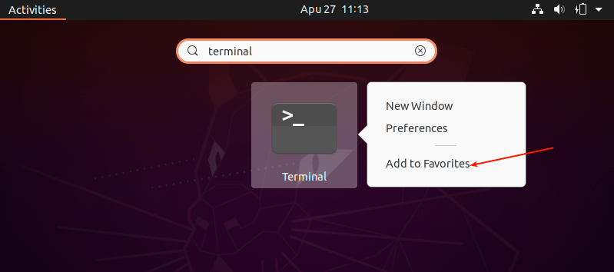

TIP: to install software from the Ubuntu GUI:
click on Ubuntu software symbol

in the dock (task bar)

Click on the search lens in the top left of the Ubuntu software window
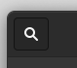
Type the name of the software you search for…
When found click on it, and in the new screen with the description of the software CLICK the Install button

TIP: If Ubuntu software doesn't show any software when you search or click on the different sub sections, reboot your VM and this should solve the issue!

Install Chromium (the community edition of Google chrome, Google chrome is not supported at the moment)

In Ubuntu software type, search and click install on Chromium

ALTERNATIVELY install Google chrome following:
- Install Google Chrome - not Chromium (the open source version of Google chrome, which is available from Ubuntu software center)!!!

To install Google chrome follow this guide:
https://linuxconfig.org/how-to-install-google-chrome-web-browser-on-ubuntu-20-04-focal-fossa

Install Visual Studio Code

search for visual studio code in Ubuntu software center and install

Install Terminator - advanced terminal where you can split the terminal screen horizontally and vertically

Important! Do not install terminator from the Ubuntu software center and install (broken snap), instead:
sudo apt-get update -y
sudo apt-get install -y terminator

GitKraken - Install from the Ubuntu software center, but do not start it. We will set it up together later!

Optional installs if needed:

Install Additional Archive Utilities
Ubuntu ships with tar, zip and unzip archiving utilities by default. To support different archive files that you can use on Ubuntu, you need to install other additional archiving utilities such as rar, unrar, p7zip-full, and p7zip-rar as shown.
In terminal:

sudo apt install rar unrar p7zip-full p7zip-rar

INSTALL ROS MELODIC

Open new terminal and complete the following commands:
- Clone installation file (copy or type the following as one line):
wget https://raw.githubusercontent.com/nitroclubs/ROS_and_simulations_install_scripts/main/install_ros_melodic.sh
- Give permissions to the file: chmod 775 install_ros_melodic.sh
- Run the script: bash ./install_ros_melodic.sh
- When the process is complete you will see the massage Complete!!! At the end of the terminal. Close the terminal!
After executing the second line, the installation procedure will start. This procedure installs ROS, git, ros-rqt and all necessary packages. Then creates catkin workspace and export workspace in bashrc. Now you are ready to use ROS.

Upgrade installed packages
As noted here, do:
sudo apt-get update
sudo apt-get dist-upgrade

CONFIGURING THE ROS DEVELOPMENT ENVIRONMENT

Start VScode (Visual Studio Code) in order to install the required extensions for software development:

When started, click on the boxes symbol on the left
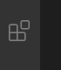
This will open the extensions menu.
Install the extension by typing the name in the search box, then clicking on the extension, you want and in the window which appears on the right click install.
Install the following extensions:
- ROS (by Microsoft)
In the bottom right corner you'll be asked to select python interpreter - click on the message. in the top middle a list of Python version will arrear, select and click on - Python 3.8 /usr/bin/python.3.8.0
- Better comments (by Arron Bond)
- Bookmarks (by Alessandro Fragnani)
- Bracket Pair Colorizer 2 (by CoenraadS)
- Prettier - Code formatter (by Prettier)
- 3D Viewer for VSCode (by slevesque)
C/C++ IntelliSense, debugging, and code browsing. (by Microsoft) is already installed
For the ones who will be programming micro controllers (i.e. Teensy, Arduino and so on):
7. PlatformIO

WE ARE READY TO GO NOW!!!!!!!!!!!!!!

Verify ROS Melodic installation

Let us try some ROS commands to make sure the installation has finished successfully. A simple way to check the functionality of ROS is to use the turtlesim simulator, which is part of the ROS installation.

Open a terminal press ctrl-alt-T or from the GUI if you can find it 😊

In the terminal run:

roscore

open another terminal and run the simulation command:

rosrun turtlesim turtlesim_node

If everything is correct, we will get the following screen:

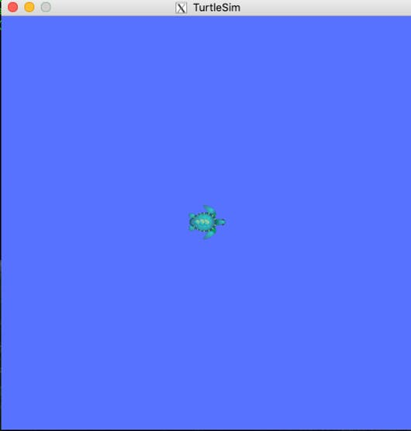

Open up yet another terminal window. Run the following:

rosrun turtlesim turtle_teleop_key

- Click the mouse in the last terminal window you created so that it has focus. Use the arrow keys to move the turtle around the screen.
- If everything goes right, you will obtain the following result on current terminal:

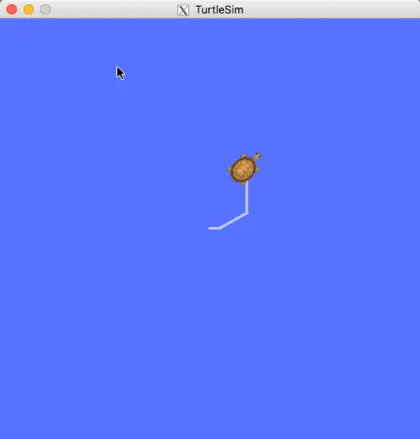

After you are done playing with the turtle:

CLOSE PROGRAMS RUNNING IN ALL OF THE TERMINALS YOU’VE OPENED!
Click with the mouse in every terminal you’ve opened and press Ctrl+C in order to stop roscore, etc.

AND NOW LET’S START LEARNING!
Don’t be discouraged, it will take time – you need to get convenient with the Linux OS, and in the same time to start understanding ROS…

TIP: In the process of learning ROS and Linux, Google search is your best friend! here are numerous tutorials and videos online…

TIP: Look for so called "cheat sheets” - this are lists with the most used commands and so on handy information.
Google for:
Linux (Ubuntu) cheat sheet
ROS cheat sheet
and choose the one you like the most.

1-st STEP – LEARN SOME LINUX

You can follow these two easy online guides and to get the hang of Linux:

https://linuxjourney.com/

http://linuxcommand.org/lc3_learning_the_shell.php

2-nd STEP – LETS DIVE INTO ROS!

1 - ROS books:

There are many ROS books in the Learning folder which is shared with you!
We can recommend this one, as easy to follow book about ROS to read and try!
ROS Robotics By Example
By Carol Fairchild, Dr. Thomas L. Harman
There are many other beginner books, you can choose one of your liking!

***---***

2 - ONLINE tutorial videos:

You can find many other ROS videos in YouTube, but the https://www.theconstructsim.com/ has very good ones!

If you are a fan of learning from videos, follow all of the videos in their Playlist named “ROS tutorial for beginners”
https://www.youtube.com/watch?v=-GZP81bTuO8&list=PLK0b4e05LnzZWg_7QrIQWyvSPX2WN2ncc&index=3

Then “ROS NAVIGATION IN 5 DAYS”
https://www.youtube.com/watch?v=5nZc5iSr5is&list=PLK0b4e05LnzZA_fWYi1_VEuBzNw9BGo6s

